Bottom Circular Rim
# Source: AI Source: Provided by: [Data Path: Persons Table -> ID Column: 1, Name_En Column: Motasem Essam] -> From: [ChatGPT] on [7/25/2026]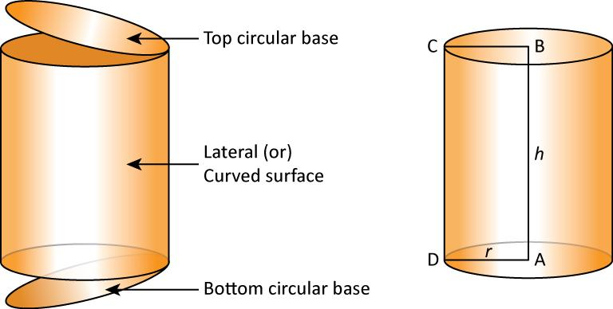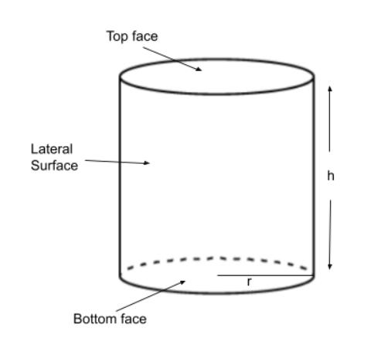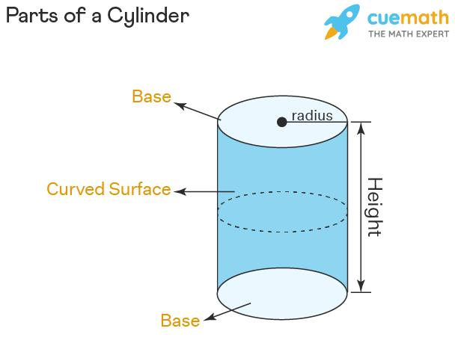

Definition
# Source: AI Source: Provided by: [Data Path: Persons Table -> ID Column: 1, Name_En Column: Motasem Essam] -> From: [ChatGPT] on [7/25/2026]
The bottom circular rim of a cylinder is the circular boundary at its lower end, surrounding the bottom base.
In a solid circular cylinder, the bottom rim bounds the lower circular base. In a hollow cylinder, the lower annular end has two circular boundaries: an outer bottom rim and an inner bottom rim.
- Position: Lower end of the cylinder.
- Shape: Circular.
- Role: Defines the boundary of the bottom base or lower opening.
- Related measurements: Radius, diameter, circumference, and—if hollow—wall thickness.

Simple Definition
# Source: AI Source: Provided by: [Data Path: Persons Table -> ID Column: 1, Name_En Column: Motasem Essam] -> From: [ChatGPT] on [7/25/2026]
The bottom circular rim is the circular edge around the bottom of a cylinder.

Geometric Representation
# Source: AI Source: Provided by: [Data Path: Persons Table -> ID Column: 1, Name_En Column: Motasem Essam] -> From: [ChatGPT] on [7/25/2026]
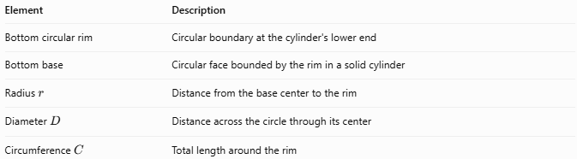
Element | Description
Bottom circular rim | Circular boundary at the cylinder's lower end
Bottom base | Circular face bounded by the rim in a solid cylinder
Radius $r$ | Distance from the base center to the rim
Diameter $D$ | Distance across the circle through its center
Circumference $C$ | Total length around the rim
The bottom rim and top rim of a right circular cylinder have equal radii and circumferences because the two bases are congruent.

Types of Bottom Circular Rims

Bottom Rim of a Solid Cylinder
# Source: AI Source: Provided by: [Data Path: Persons Table -> ID Column: 1, Name_En Column: Motasem Essam] -> From: [ChatGPT] on [7/25/2026]
The single circular boundary surrounding the solid cylinder's bottom base.

Outer Bottom Circular Rim
# Source: AI Source: Provided by: [Data Path: Persons Table -> ID Column: 1, Name_En Column: Motasem Essam] -> From: [ChatGPT] on [7/25/2026]
The larger circular boundary along the outside of a hollow cylinder's lower end.
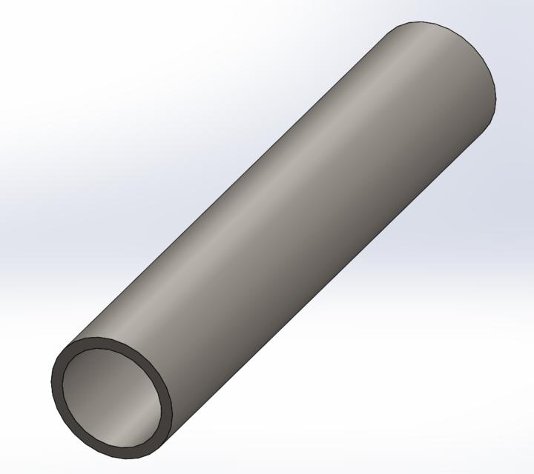

Inner Bottom Circular Rim
# Source: AI Source: Provided by: [Data Path: Persons Table -> ID Column: 1, Name_En Column: Motasem Essam] -> From: [ChatGPT] on [7/25/2026]
The smaller circular boundary surrounding the hollow opening at the lower end of a tube.
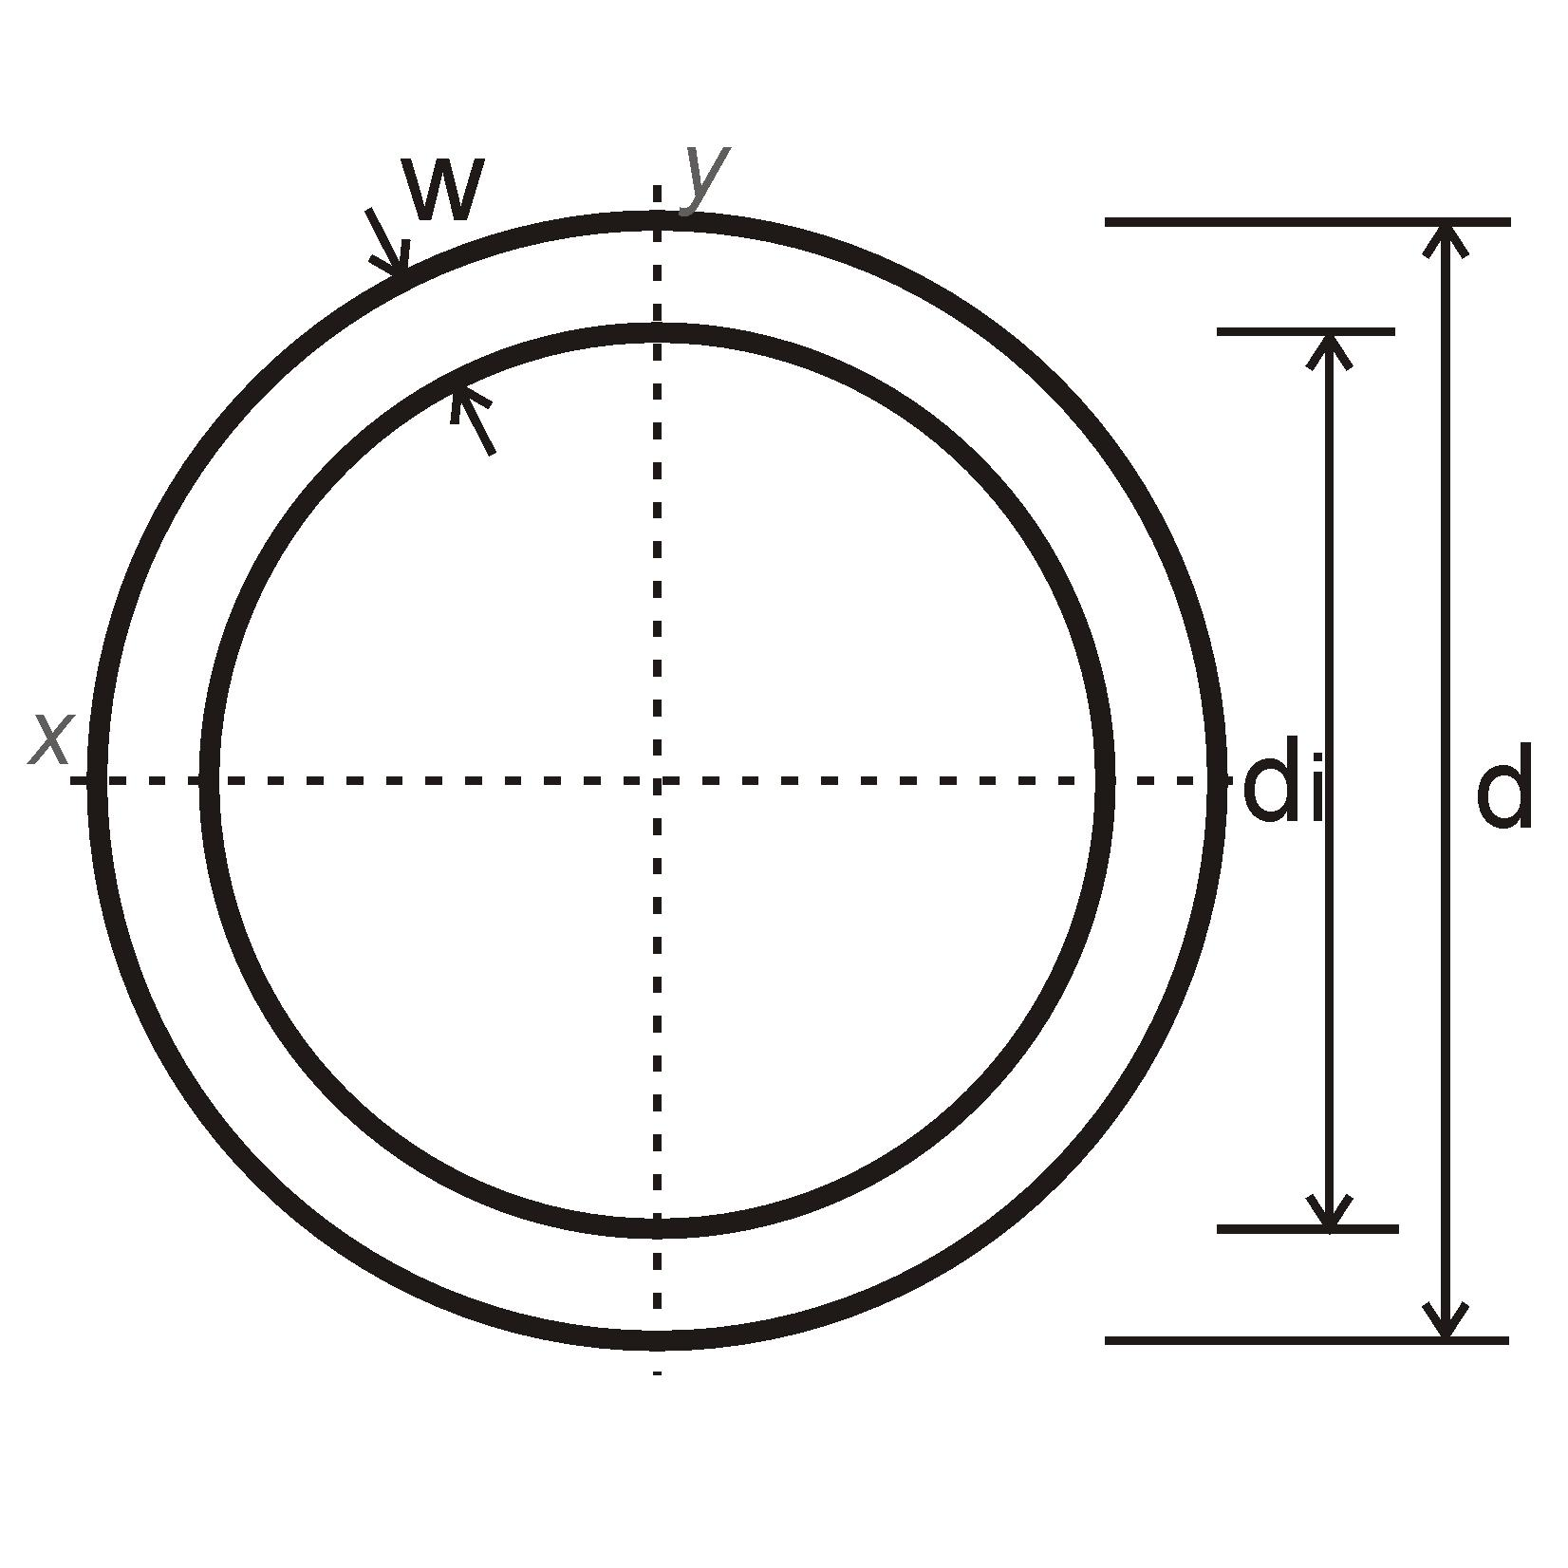

Mathematical Properties and Formulas

Circumference of the bottom circular rim
# Source: AI Source: Provided by: [Data Path: Persons Table -> ID Column: 1, Name_En Column: Motasem Essam] -> From: [ChatGPT] on [7/25/2026]
For a solid cylinder with bottom-base radius $r$:
$$\boxed{C_{b}=2πr}$$
Using the diameter $D=2r$:
$$\boxed{C_{b}=πD}$$
For a hollow cylinder, the outer and inner bottom-rim circumferences are:
$$C_{o}=2πR$$
$$C_{i}=2πr$$
where $R$ is the outer radius and $r$ is the inner radius.

Area of the bottom base
# Source: AI Source: Provided by: [Data Path: Persons Table -> ID Column: 1, Name_En Column: Motasem Essam] -> From: [ChatGPT] on [7/25/2026]
For a solid cylinder, the bottom circular base has area:
$$\boxed{A_{b}=πr^{2}}$$
For a hollow cylinder, the bottom annular face has area:
$$\boxed{A_{b}=π(R^{2}-r^{2})}$$
The rim itself is a boundary line, so its circumference is a length; the base face has an area.

Relationship between the top and bottom rims
# Source: AI Source: Provided by: [Data Path: Persons Table -> ID Column: 1, Name_En Column: Motasem Essam] -> From: [ChatGPT] on [7/25/2026]
For a cylinder with parallel, congruent circular bases:
$$\boxed{C_{top}=C_{bottom}}$$
For a solid cylinder:
$$r_{top}=r_{bottom}$$
For a hollow cylinder, the corresponding outer radii are equal, and the corresponding inner radii are equal.

Worked Examples

Example 1 — Find the bottom-rim circumference
# Source: AI Source: Provided by: [Data Path: Persons Table -> ID Column: 1, Name_En Column: Motasem Essam] -> From: [ChatGPT] on [7/25/2026]
A solid cylinder has a bottom-base radius of $7 cm$. Find the circumference of its bottom rim.
Solution:
$$C_{b}=2πr$$
$$C_{b}=2π(7)$$
$$\boxed{C_{b}=14π cm≈43.98 cm}$$

Example 2 — Find the radius from the circumference
# Source: AI Source: Provided by: [Data Path: Persons Table -> ID Column: 1, Name_En Column: Motasem Essam] -> From: [ChatGPT] on [7/25/2026]
The bottom circular rim of a cylinder has a circumference of $20π m$. Find its radius.
Solution:
$$r=\frac{C_{b}}{2π}$$
$$r=\frac{20π}{2π}$$
$$\boxed{r=10 m}$$

Example 3 — Find the area of a hollow cylinder's bottom face
# Source: AI Source: Provided by: [Data Path: Persons Table -> ID Column: 1, Name_En Column: Motasem Essam] -> From: [ChatGPT] on [7/25/2026]
A hollow cylinder has an outer bottom-rim radius of $6 cm$ and an inner bottom-rim radius of $4 cm$. Find the area of its bottom annular face.
Solution:
$$A_{b}=π(R^{2}-r^{2})$$
$$A_{b}=π(6^{2}-4^{2})$$
$$A_{b}=π(36-16)$$
$$\boxed{A_{b}=20π{ cm}^{2}≈62.83{ cm}^{2}}$$

Comparison with Related Concepts
# Source: AI Source: Provided by: [Data Path: Persons Table -> ID Column: 1, Name_En Column: Motasem Essam] -> From: [ChatGPT] on [7/25/2026]
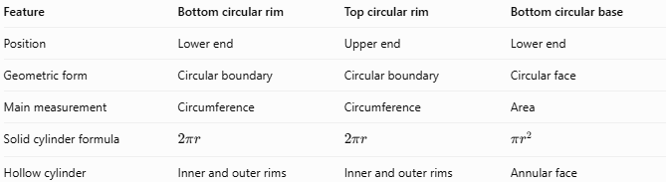
Feature | Bottom circular rim | Top circular rim | Bottom circular base
Position | Lower end | Upper end | Lower end
Geometric form | Circular boundary | Circular boundary | Circular face
Main measurement | Circumference | Circumference | Area
Solid cylinder formula | $$2πr$$ | $$2πr$$ | $$πr^{2}$$
Hollow cylinder | Inner and outer rims | Inner and outer rims | Annular face

Applications
# Source: AI Source: Provided by: [Data Path: Persons Table -> ID Column: 1, Name_En Column: Motasem Essam] -> From: [ChatGPT] on [7/25/2026]
The bottom circular rim is useful for:
- Measuring the lower edge of cylindrical containers.
- Designing pipe ends and hollow cylindrical fittings.
- Determining the circumference of a cylinder's lower boundary.
- Calculating the annular area at the bottom of a hollow tube.
- Describing the geometry of cylindrical bases and their boundaries.

Key Points
# Source: AI Source: Provided by: [Data Path: Persons Table -> ID Column: 1, Name_En Column: Motasem Essam] -> From: [ChatGPT] on [7/25/2026]
- The bottom circular rim is the circular boundary at the lower end of a cylinder.
- Its circumference is $C_{b}=2πr=πD$.
- The rim is distinct from the bottom base face.
- The top and bottom rims of a cylinder have equal circumferences when their bases are congruent.
- A hollow cylinder has outer and inner bottom rims.
- The area of the annular bottom face is $π(R^{2}-r^{2})$.

Conclusion
# Source: AI Source: Provided by: [Data Path: Persons Table -> ID Column: 1, Name_En Column: Motasem Essam] -> From: [ChatGPT] on [7/25/2026]
The bottom circular rim is the circular boundary surrounding the lower end of a cylinder. It defines the edge of the bottom base or opening and can be measured using its radius, diameter, and circumference. In a hollow cylinder, the inner and outer bottom rims bound the annular end face.

